SIMATS ENGINEERING
ASSESSMENT TOOL 1

COURSE CODE: CSA1442 COURSE NAME: Compiler Design for Higher
Level Processing

COURSE OUTCOME COVERED

CO2: Construct top-down and bottom up parsers using CFG for parsing conflicts and error recovery for efficient syntax tree generation. (BL3)

Assessment Tool Weightage: 40%

QUESTIONS:4 Total Marks:50
Annexure A

DESIGN TASK

Code of Conduct:

I ____M.Niharika(192365019)___ (Name / Reg No) certify that this submission is my original work and that I have adhered to the guidelines specified for this assessment.
I understand that any violation of academic integrity rules will result in disciplinary action.

Signature of the student:
Niharika

Course Faculty

Task:
Q1)Construct an LL(1) predictive parsing table for the given grammar and demonstrate its application by parsing the
specified input string step-by-step, clearly showing stack operations, input symbols, and parsing actions.
.
Grammar:
E → T E&#39;
E&#39; → + T E&#39; | ε
T → F T&#39;
T&#39; → * F T&#39; | ε
F → (E) | id
Conditions:
• Remove left recursion (if any)
• Compute FIRST and FOLLOW sets
• Construct LL(1) parsing table
Test Case:
Input String:
id + id * id
Expected Output:
• Step-by-step parsing actions
• Final result: String Accepted
Program:

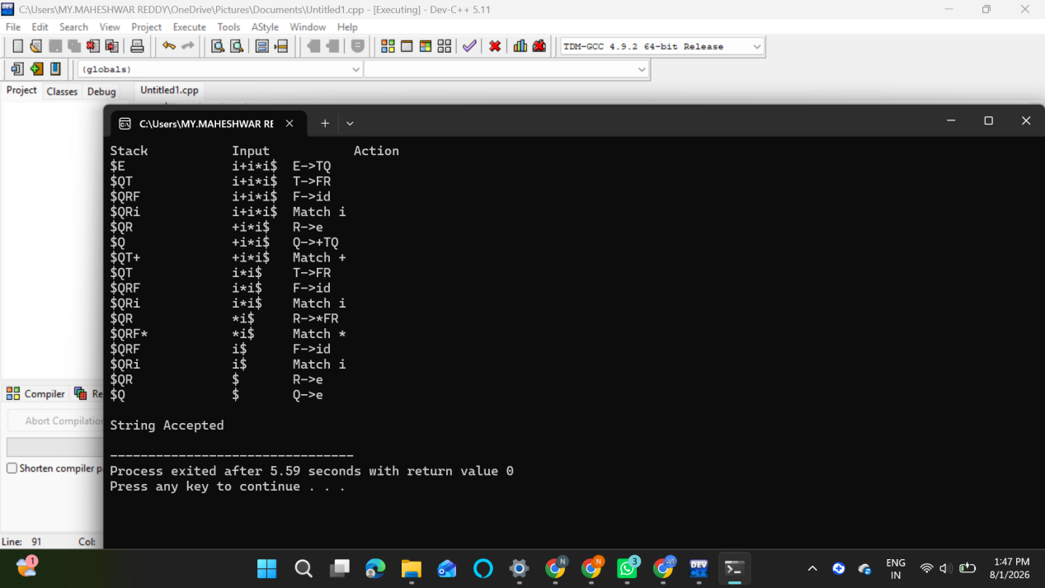
Q2. Shift-Reduce Parsing (Application Level)
Task:
Apply shift-reduce parsing to the given grammar and input string, and demonstrate the complete parsing process by
showing each step with stack contents, remaining input, and parsing actions (shift, reduce, accept, or error), clearly
indicating all reductions and decisions made during parsing.
Grammar:
E → E + E
E → E * E
E → id
Conditions:
• Show stack, input buffer, and action at each step
• Resolve conflicts using precedence (* has higher precedence than +*)
Test Case:
Input:
id + id * id
Expected Output:
• Sequence of actions: Shift / Reduce / Accept
• Final result: String Accepted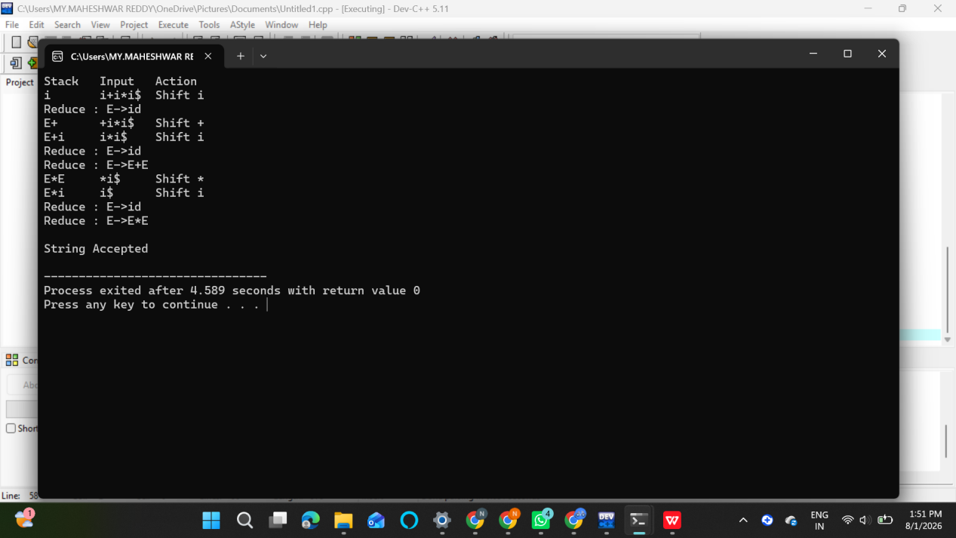
Q3.Construct the LR parsing tables for the given grammar and perform a detailed comparison of different LR
parsing techniques (SLR, LALR, and CLR), highlighting their construction steps, state transitions, table sizes, and
any conflicts encountered.
S → L = R | R
L → * R | id
R → L
Tasks

(i) CLR (Canonical LR) Design
Construct the canonical collection of LR(1) items
Build the CLR parsing table
Show all item sets and transitions
(ii) SLR Parser Design
Compute FIRST and FOLLOW sets
Construct the SLR parsing table
Identify and explain any shift-reduce or reduce-reduce conflicts
(iii) LALR Parser Design
Merge compatible LR(1) states
Construct the LALR parsing table
Compare with CLR and show how states are reduced
(iv) Parsing Demonstration
Using any one of the constructed parsing tables,
parse the input string:
id = * id
Show:
Stack
Input buffer
Action (Shift / Reduce / Accept)
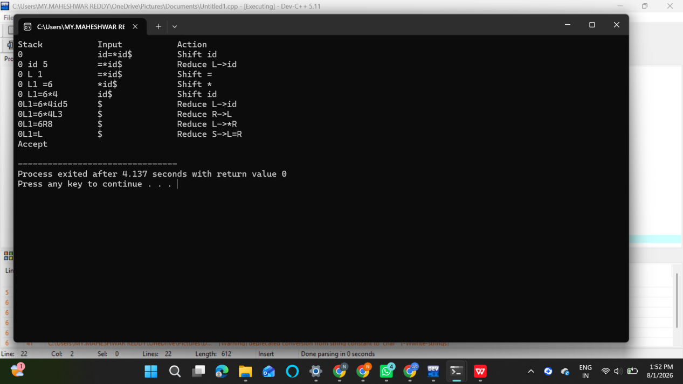

Q4. Critically evaluate the effectiveness of Parsing Expression Grammars (PEG) as a modern parsing technique by comparing them with traditional LL and LR parsers in terms of ambiguity handling, grammar expressiveness, implementation complexity, performance, and real-world applicability.

Your answer should:
- Analyze how PEG parsers resolve ambiguity differently from CFG-based parsers
- Compare PEG with LL and LR parsing in terms of:
  - Grammar expressiveness
  - Ease of implementation
  - Performance and backtracking
- Examine real-world adoption (e.g., Python’s PEG parser) and justify why PEG was preferred
- Critically evaluate limitations of PEG (e.g., lack of left recursion support, ordered choice behavior)
- Conclude whether PEG is suitable for all programming languages or only specific cases, with justification
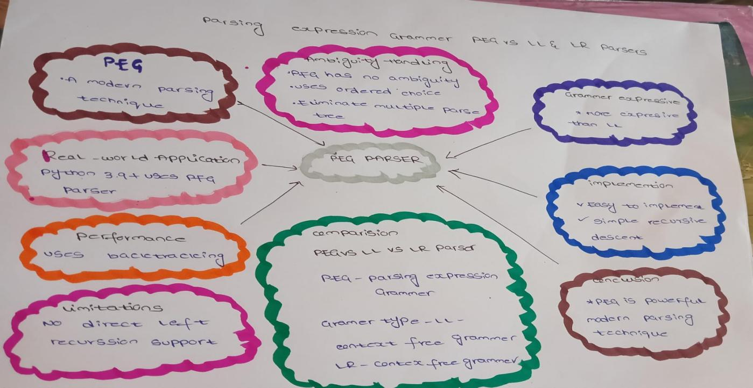
RUBRICS FOR CALCULATION:

Criteria | Weightage | Level 4 – Exemplary | Level 3 – Proficient | Level 2 – Developing | Level 1 – Beginning
Understanding of Concepts | 20 | Demonstrates thorough understanding and integrates multiple concepts effectively | Good understanding with proper integration of most concepts | Basic understanding with partial integration | Poor understanding with no integration
Design & Implementation | 25 | Well-designed solution with systematic and optimal implementation | Correct design with minor issues | Basic design with errors or inefficiencies | Incorrect or incomplete design
Parser/Algorithm Construction | 20 | Accurate construction of parser/algorithm with complete logic | Mostly correct construction with minor errors | Partial construction with missing logic | Incorrect or incomplete construction
Analysis & Validation | 15 | Insightful analysis with correct validation and justification | Good analysis with reasonable justification | Basic analysis with limited validation | Poor or incorrect analysis
Documentation & Presentation | 20 | Well-structured documentation with diagrams, steps, and clarity | Organized documentation with required details | Basic documentation with missing details | Poor or incomplete documentation

